**LAB # 06**



**Fall 2022**

**CSE101L Computer Fundamentals Lab**

Submitted by: **Haris Khan**

Registration No. : **60032**

Class Section: **A**

“On my honor, as student of University of Engineering and Technology, I have neither given nor received unauthorized assistance on this academic work.”

Student Signature: ______________

Submitted to:

**Engr. Abdullah Hamid**

December 15, 2022

Department of Computer Systems Engineering

University of Engineering and Technology, Peshawar

***Part#01:***

How you will access a Wi-Fi router admin panel attach screenshots of each step.

# ***Step#01:***

Click on search below and type “command prompt”.

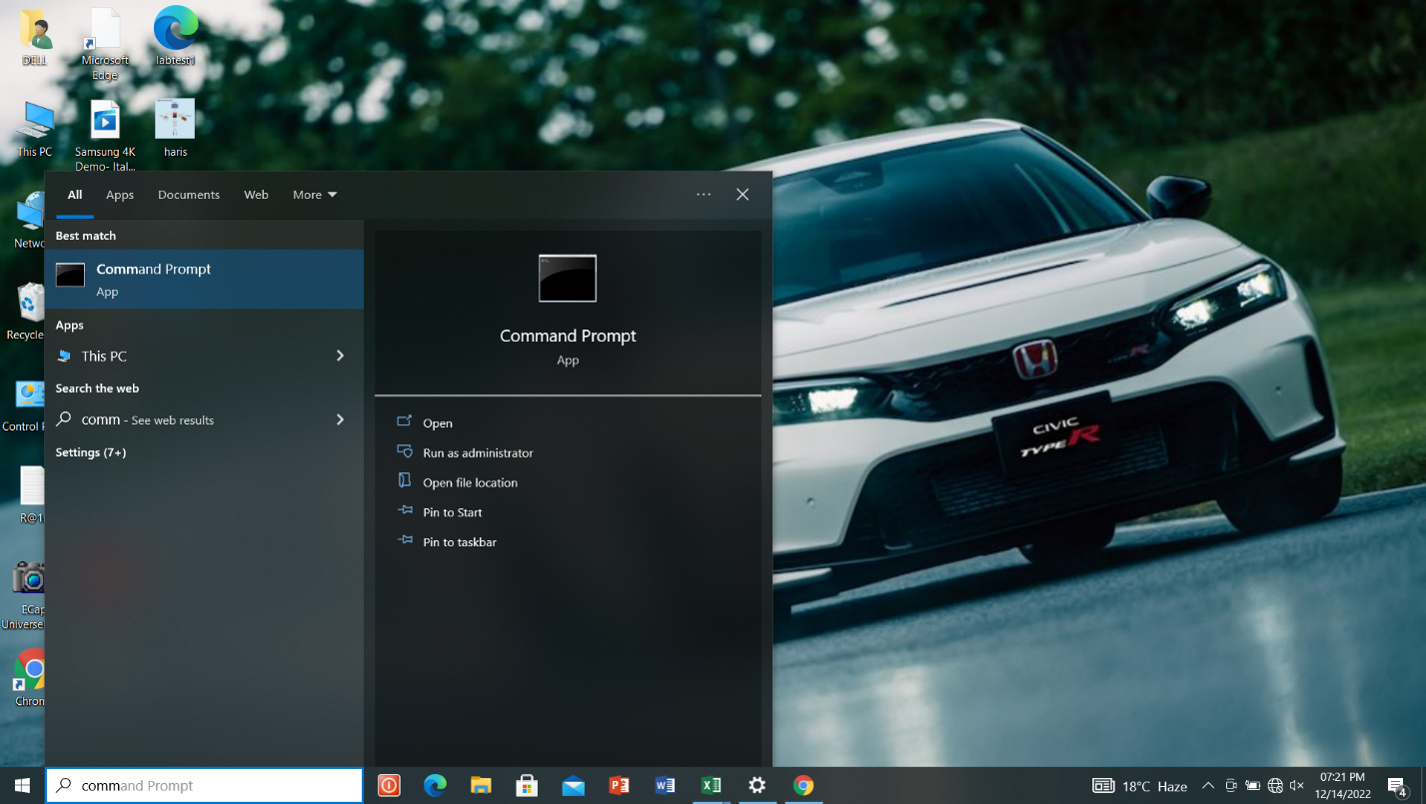

# ***Step#02:***

Click on “Command Prompt” and type “inconfig”and then enter

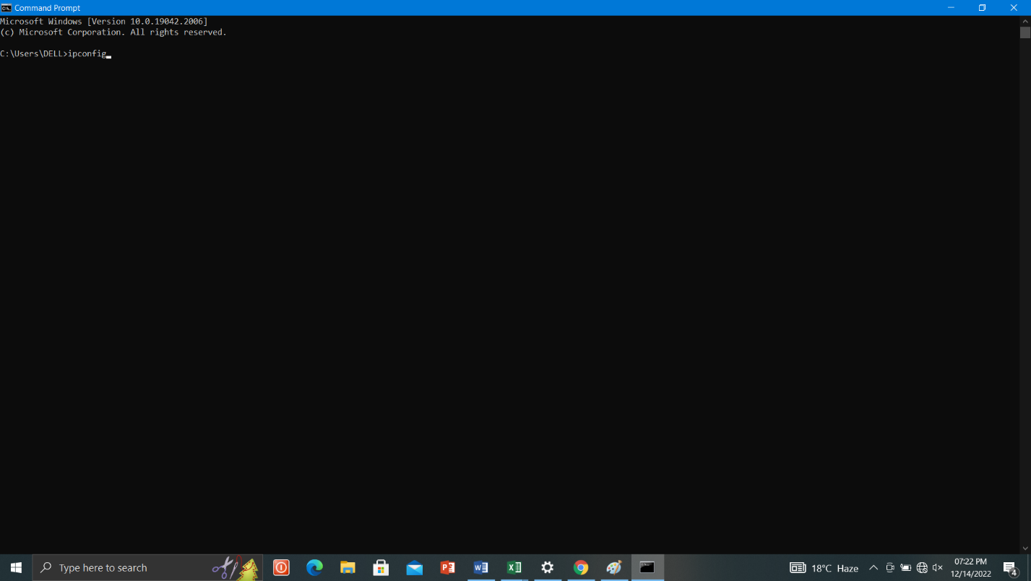

# ***Step#03:***

After enter there appears IPv4 address.

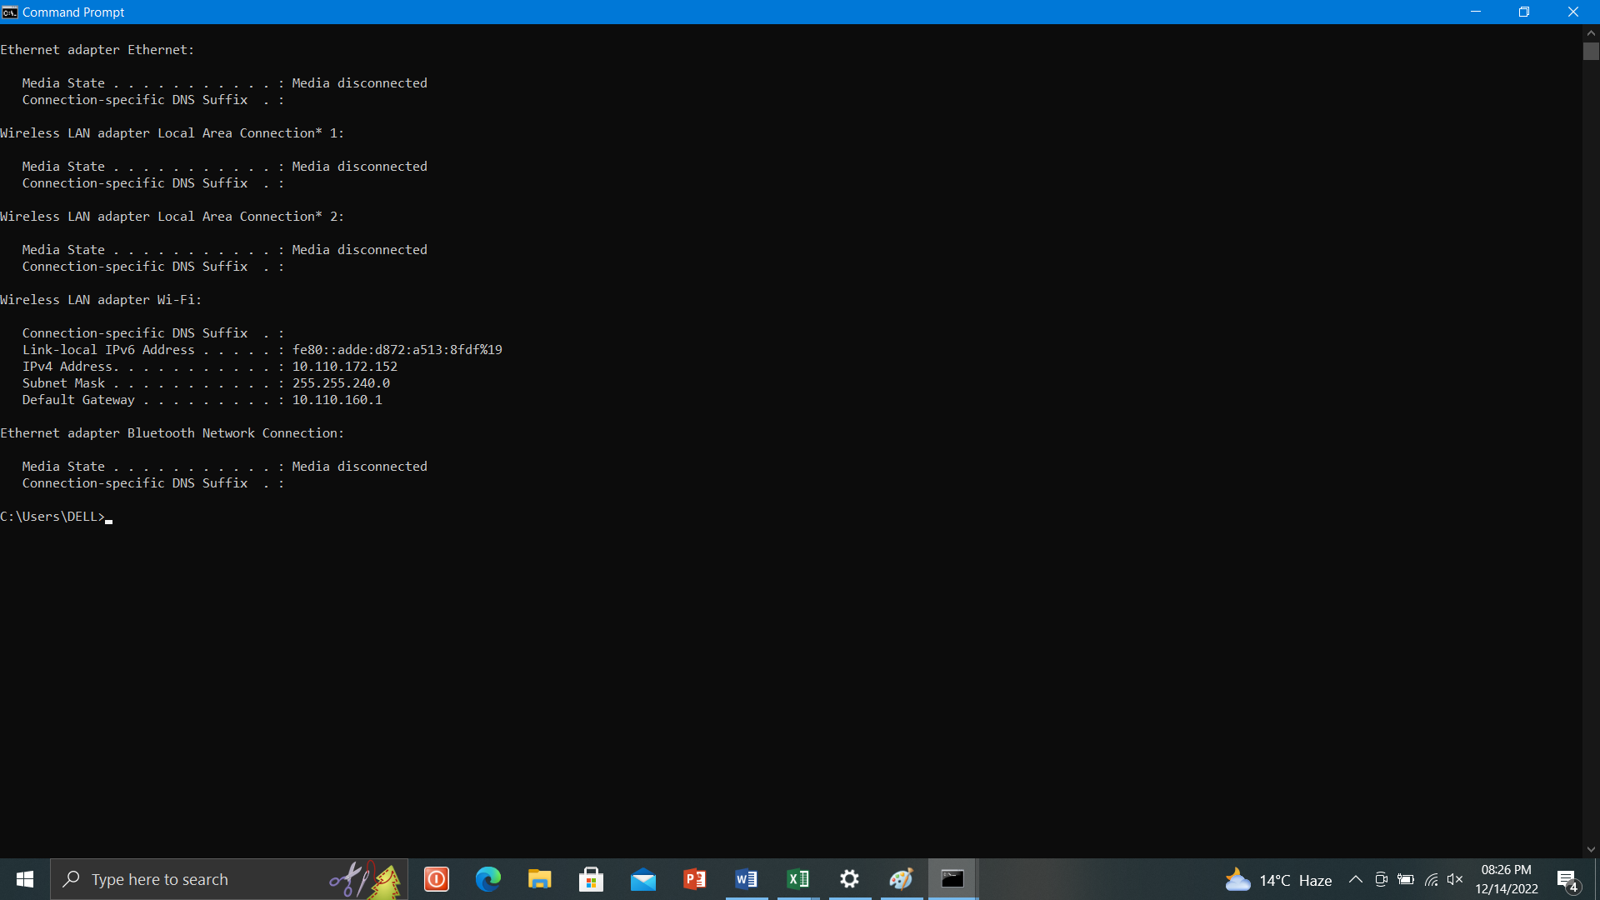

# ***Step#04:***

Identify THE IP address of the router. Most routers are manufactured to use a default address such as 192.168.0.1, 192.168.1.1, 192.168.2.1, 192.168.1.100.

# ***Step#05:***

In a web browser, such as Microsoft Edge, Internet Explorer, Chrome or Firefox request a connection to the router. Do this by typing the router’s IP address in the browser’s address bar.

# ***Step#06:***

Enter the administrative login information-user name and password-to authenticate and access the admin settings.

***NOTE:***

Some routers are not accessed in the way described here. Most are, but a few require different steps, such as using a mobile app.

***Part#02:***

Explain how you will send an email with an attachment that has a size more than 30mb.

# ***Step#01:***

Upload your file to Google drive.

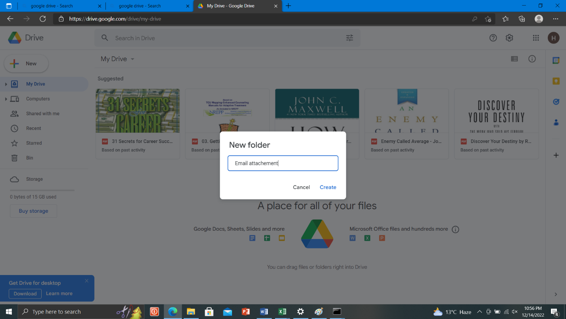

# ***Step#02:***

Go to email compose. Write recipient email first.

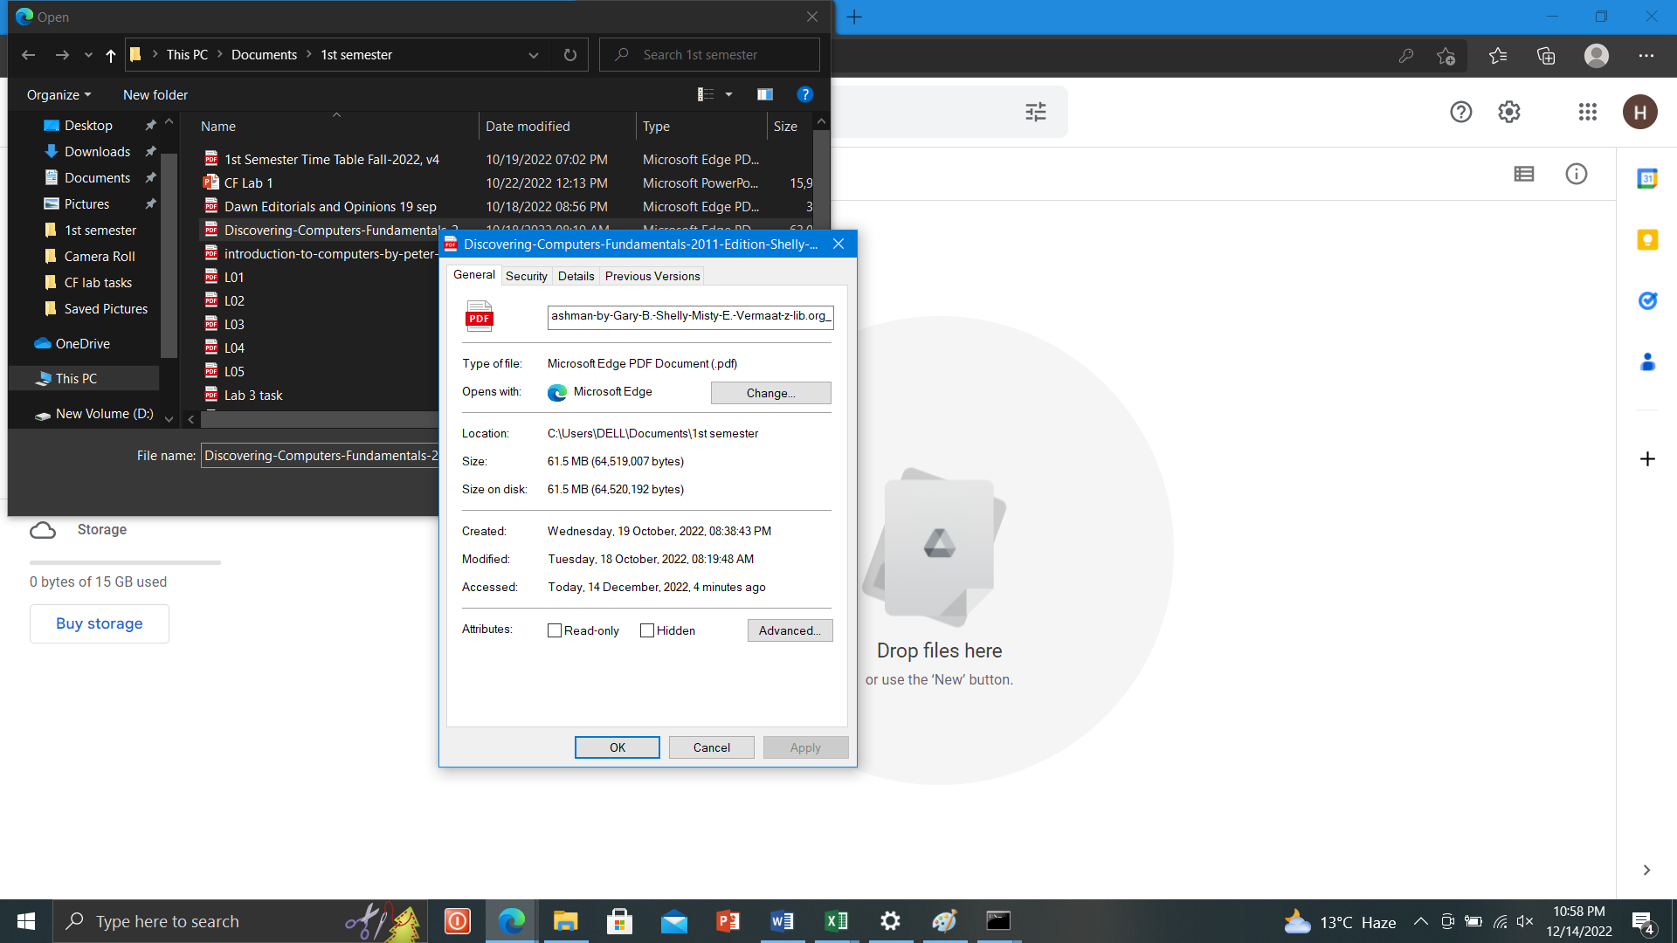

# ***Step#03:***

Attach your file from Google drive. Click on insert and then click on send.

